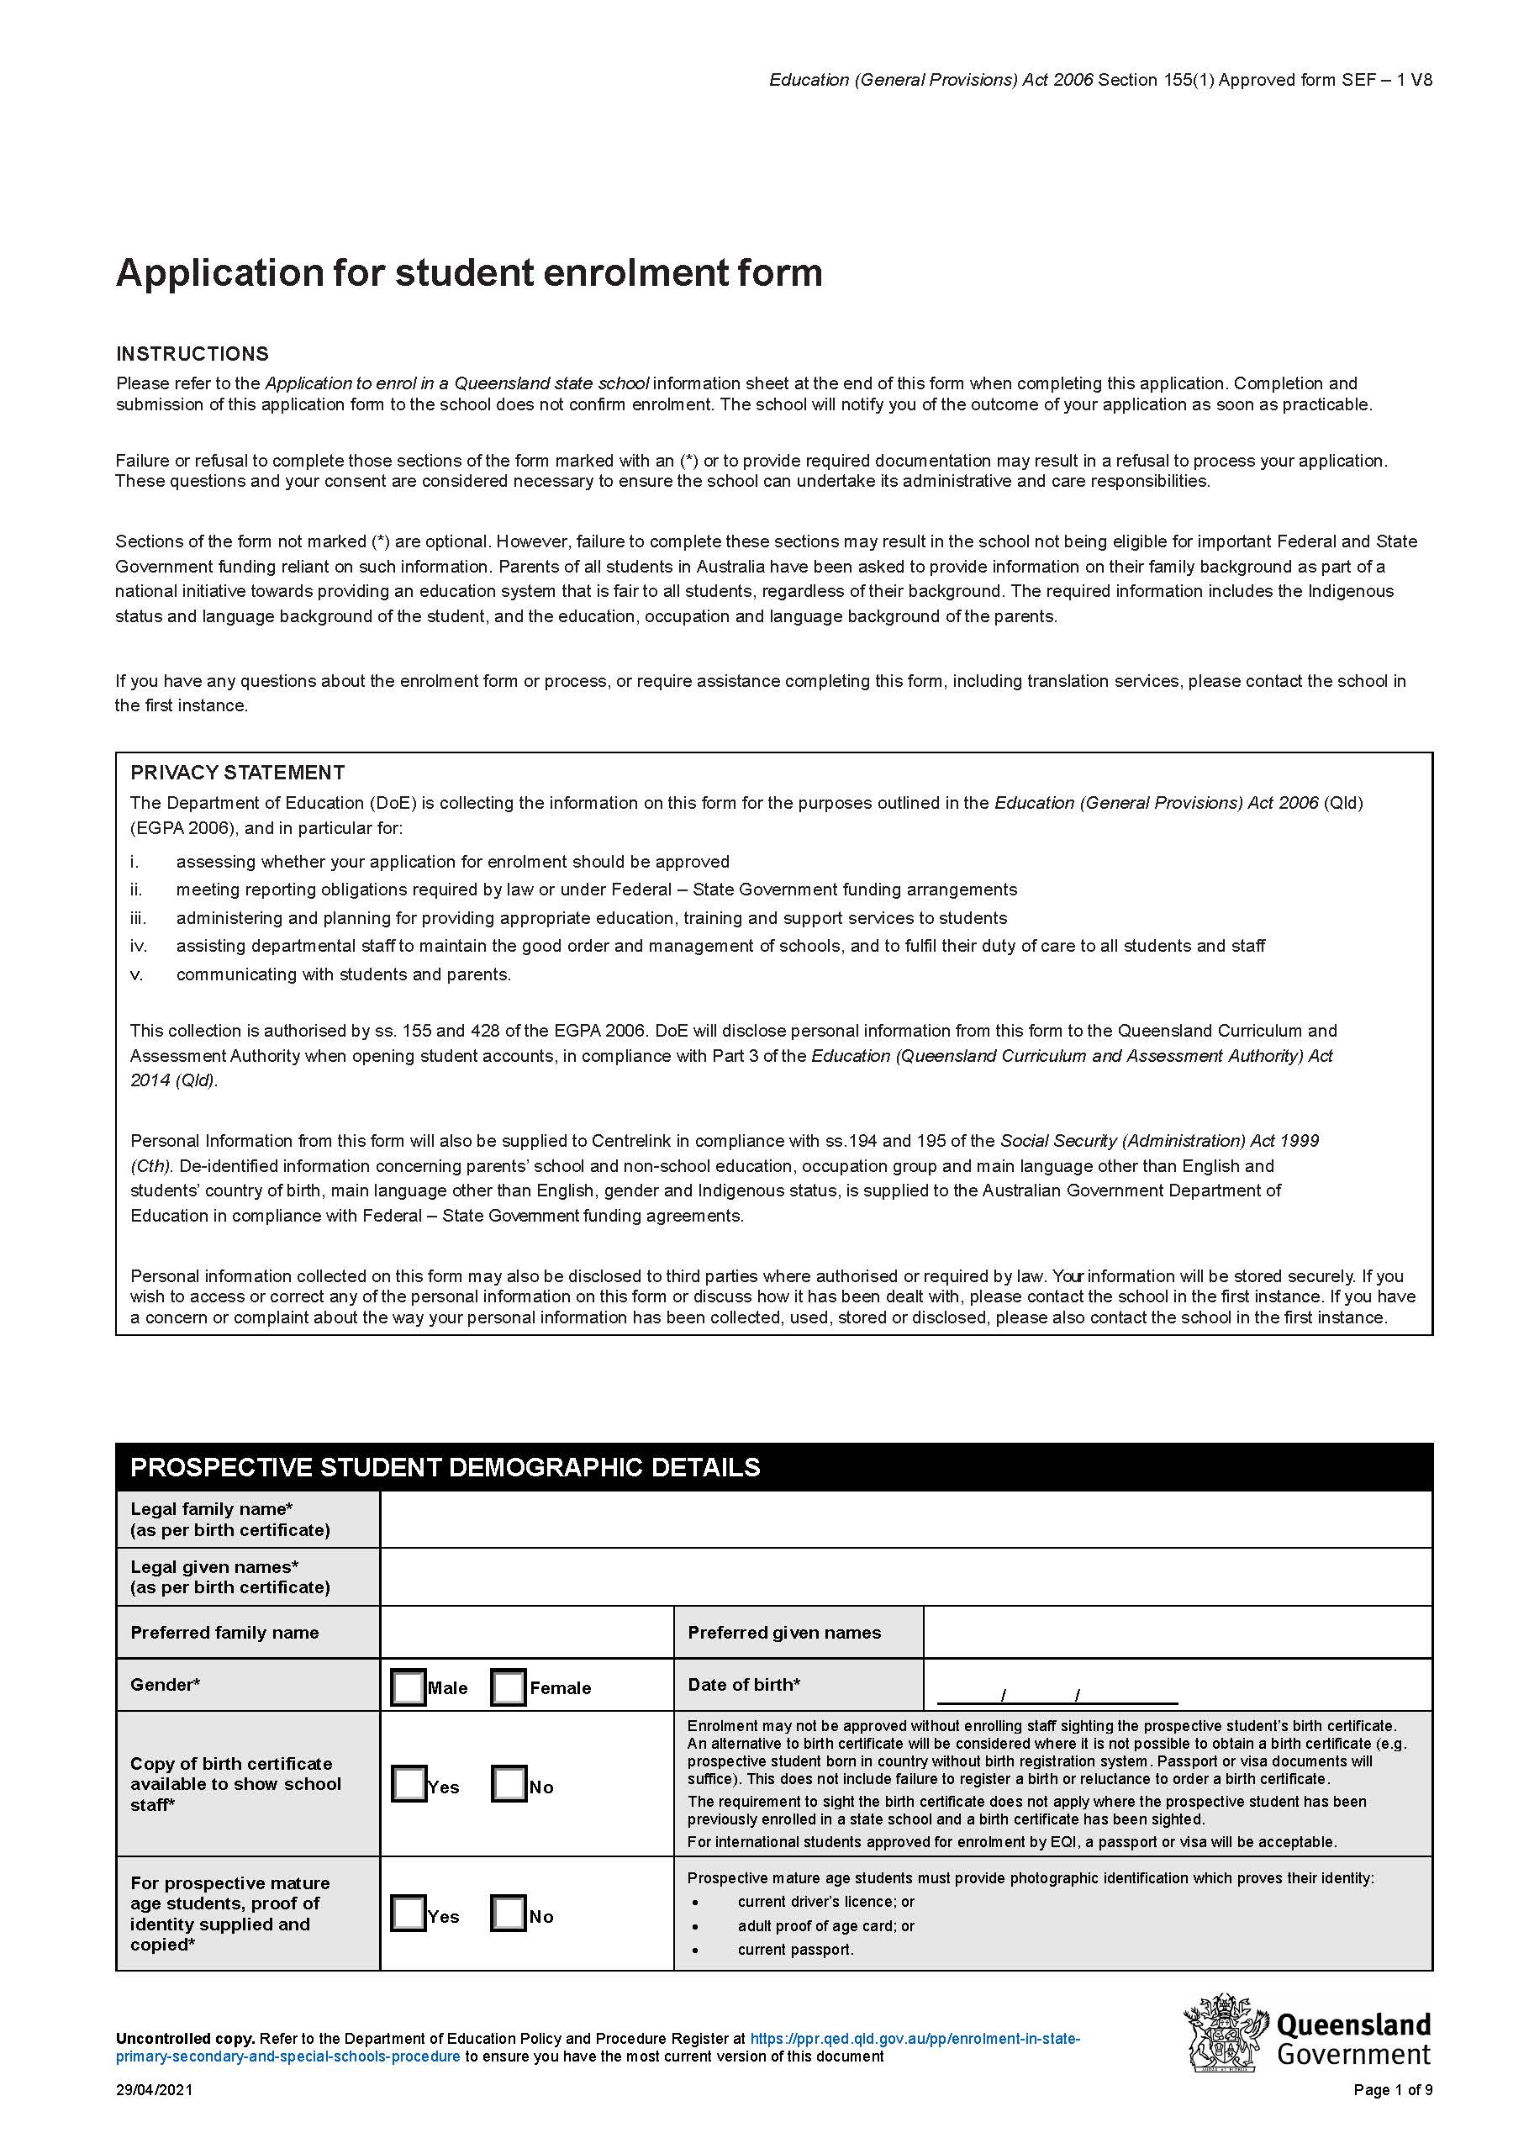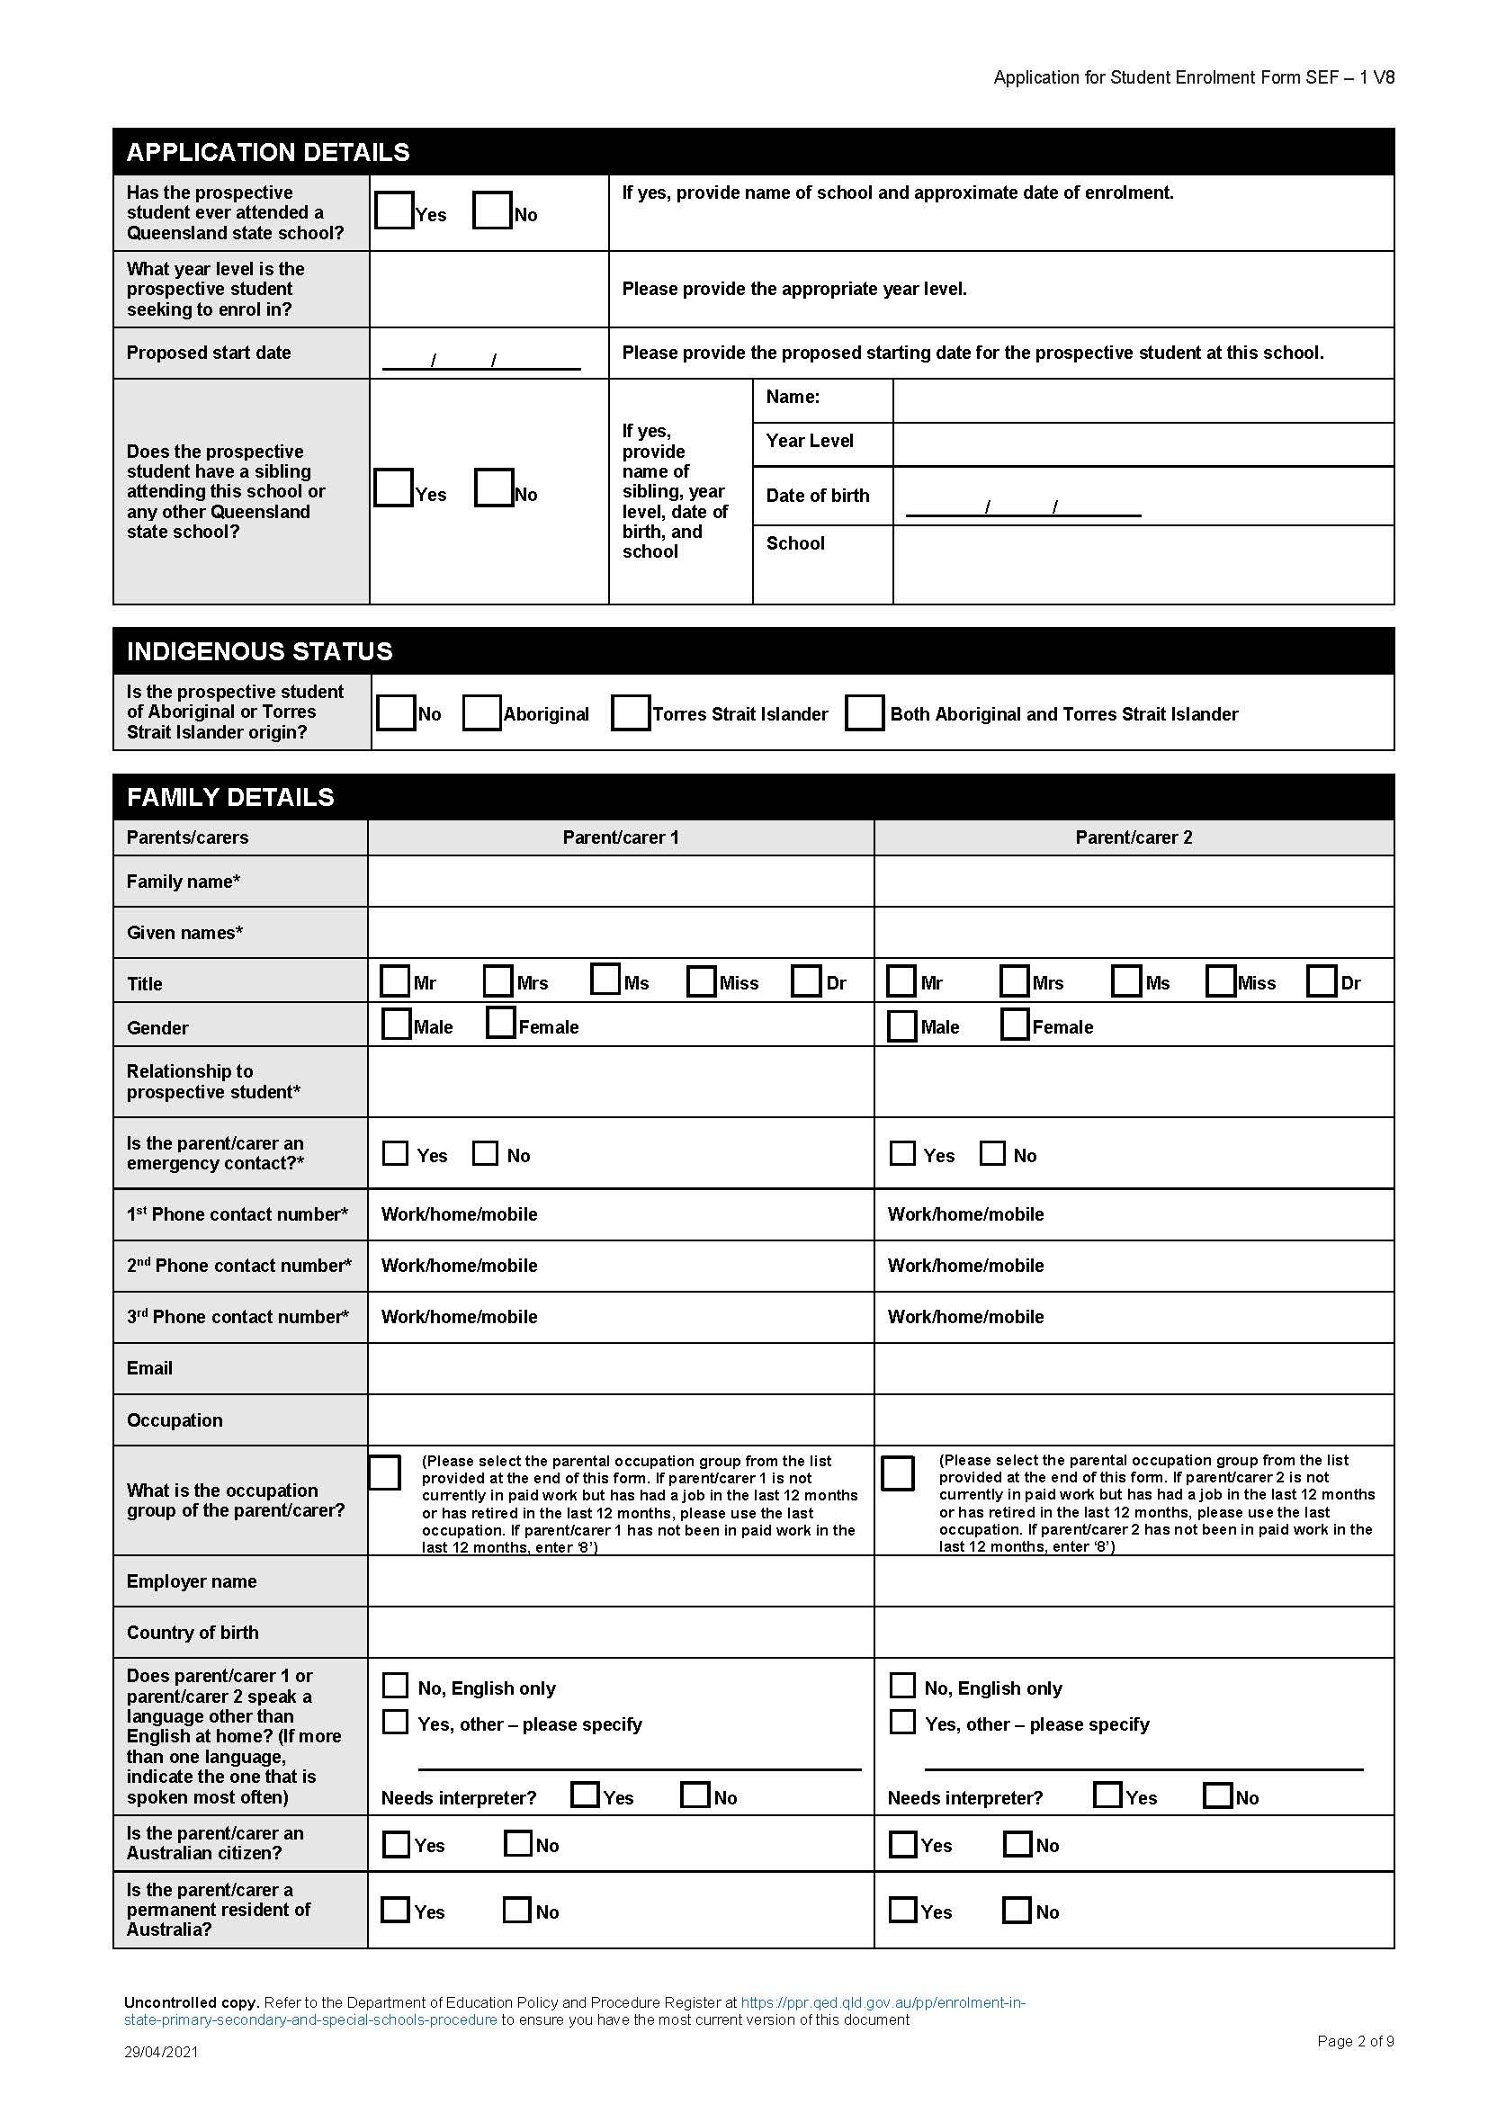

Redland Bay State School
125-141 Gordon Road, Redland Bay, Qld, 4165 Ph: 3479 4222

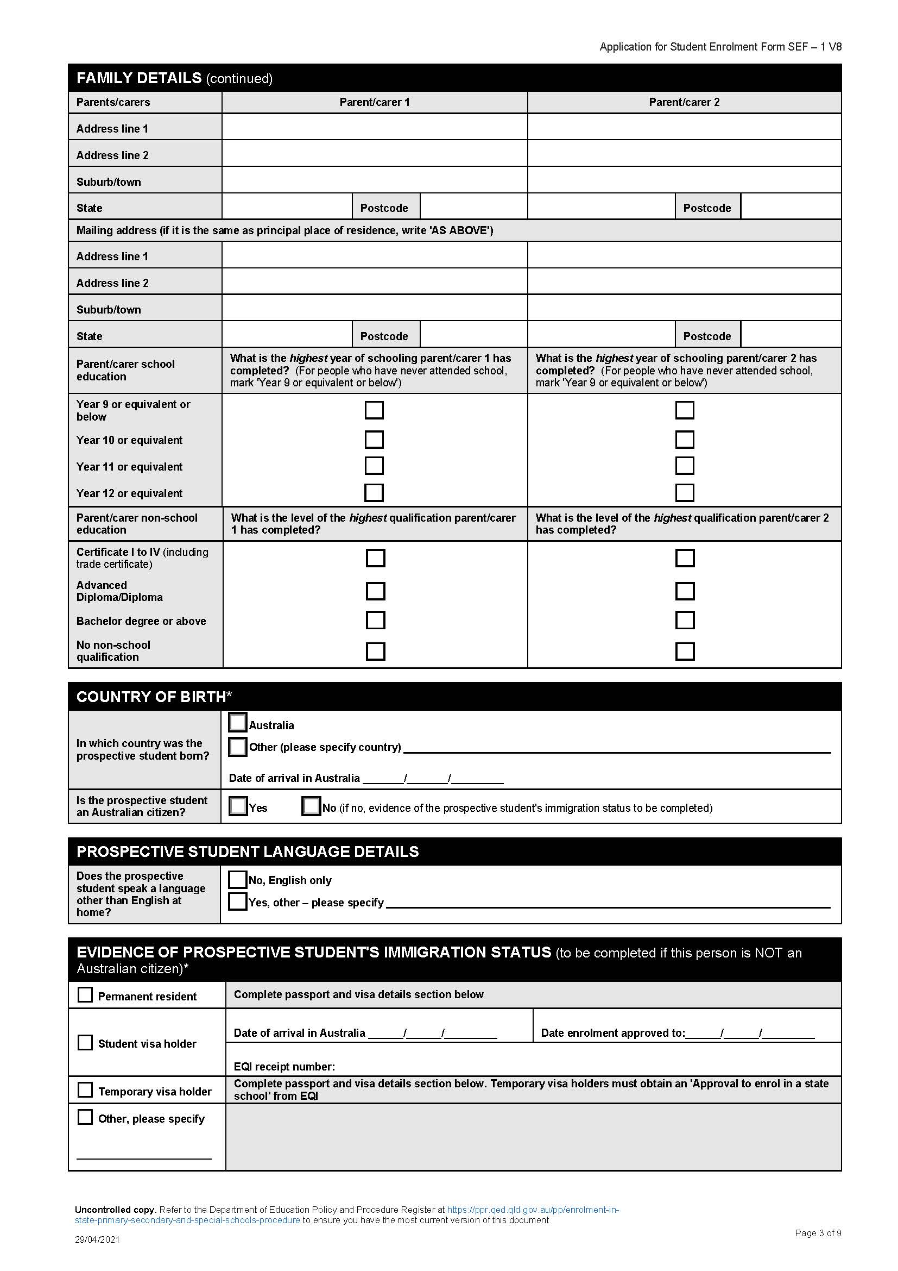
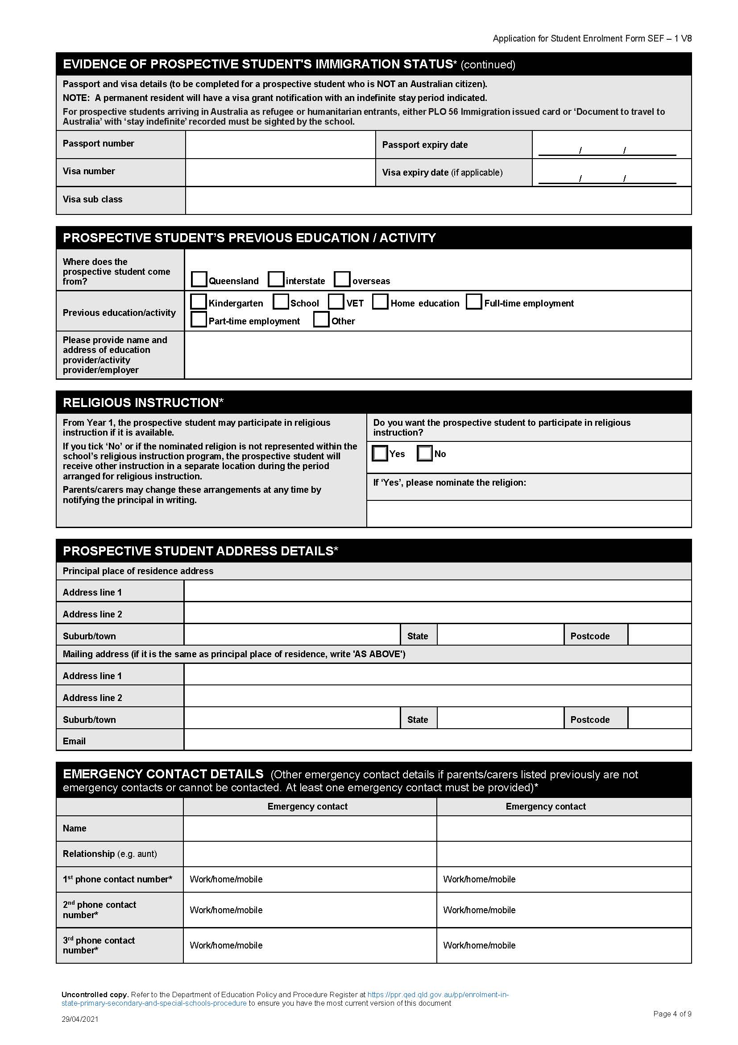
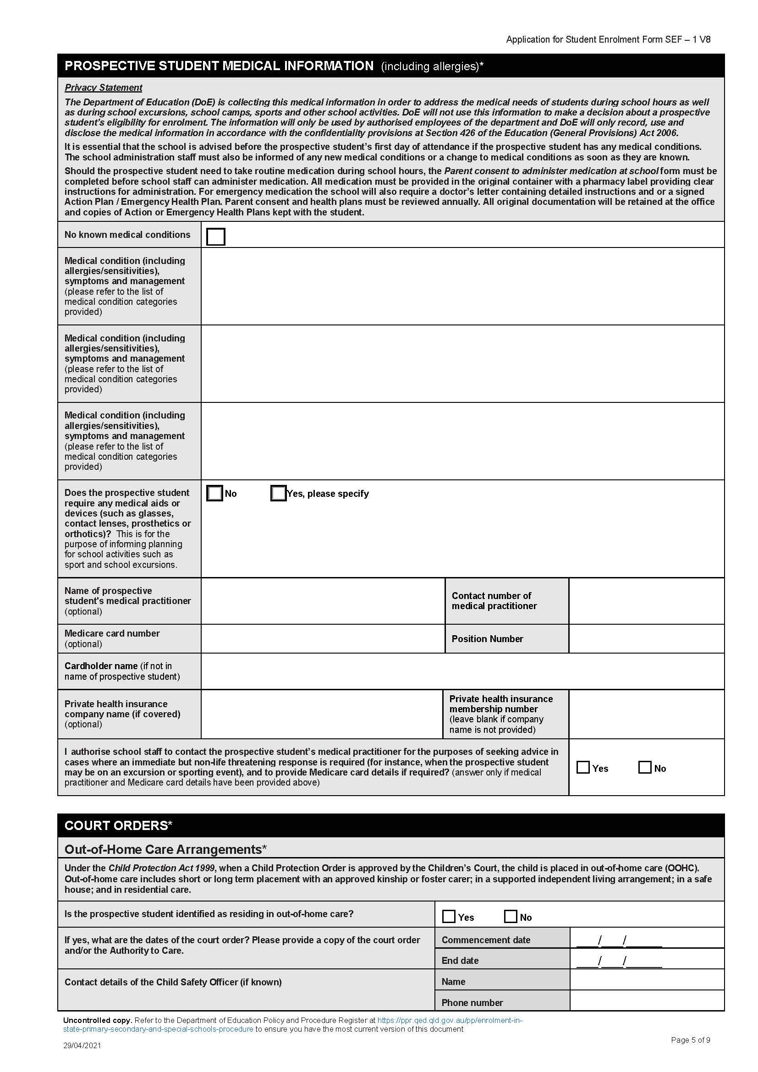
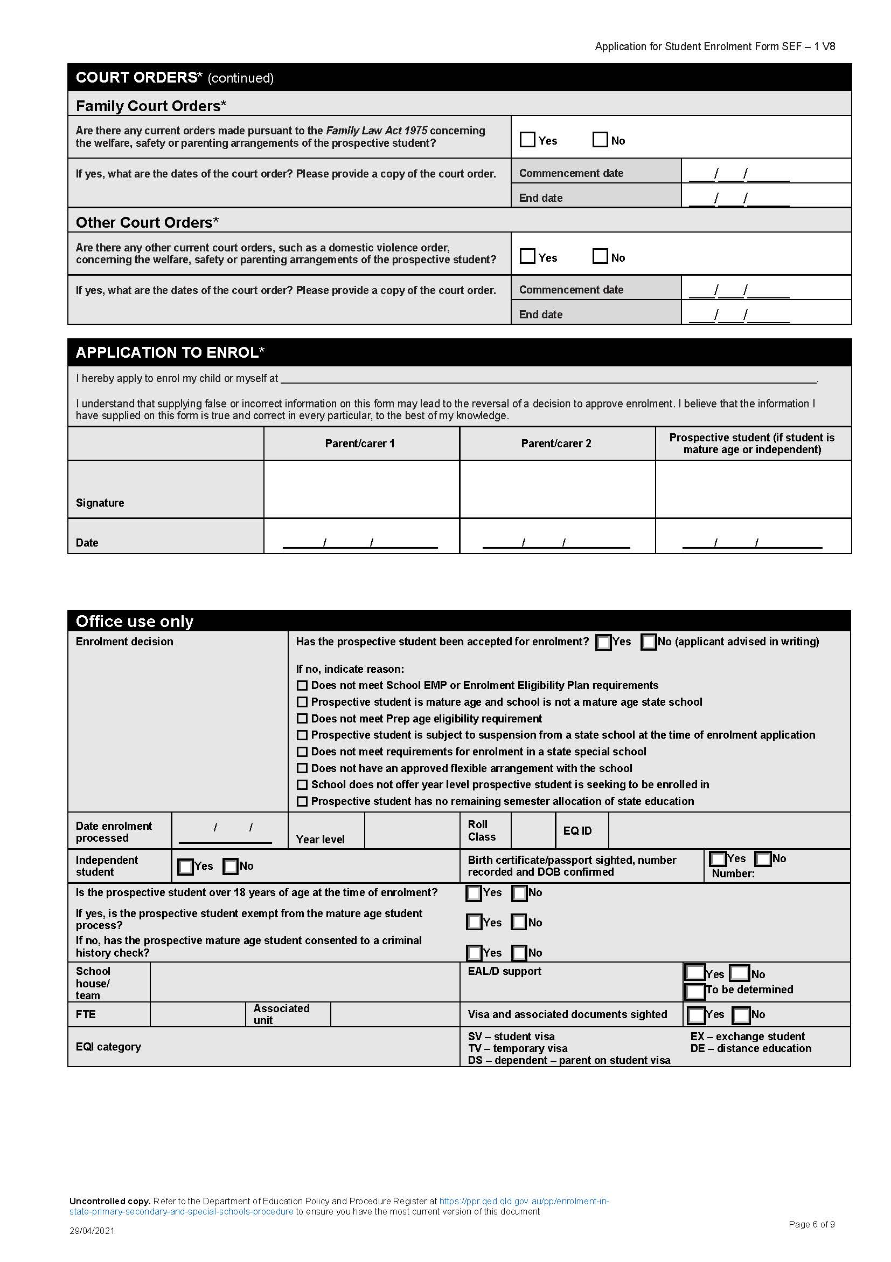
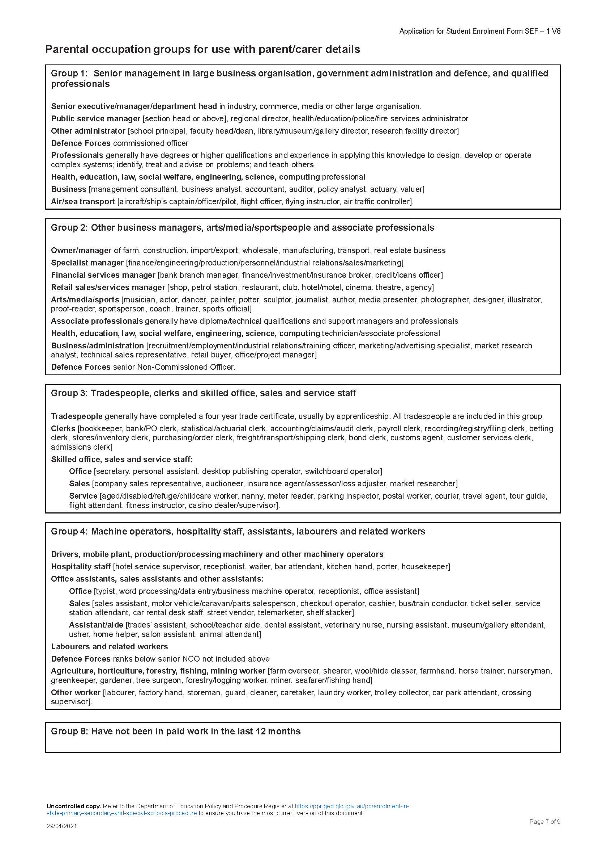
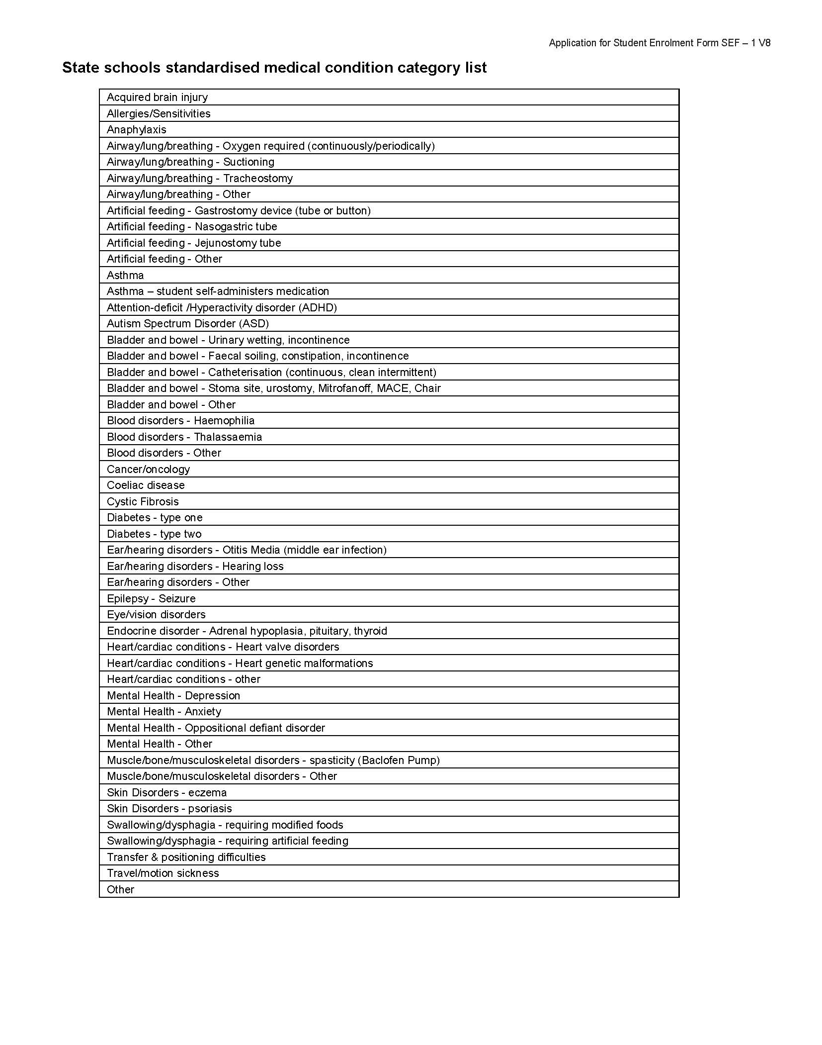
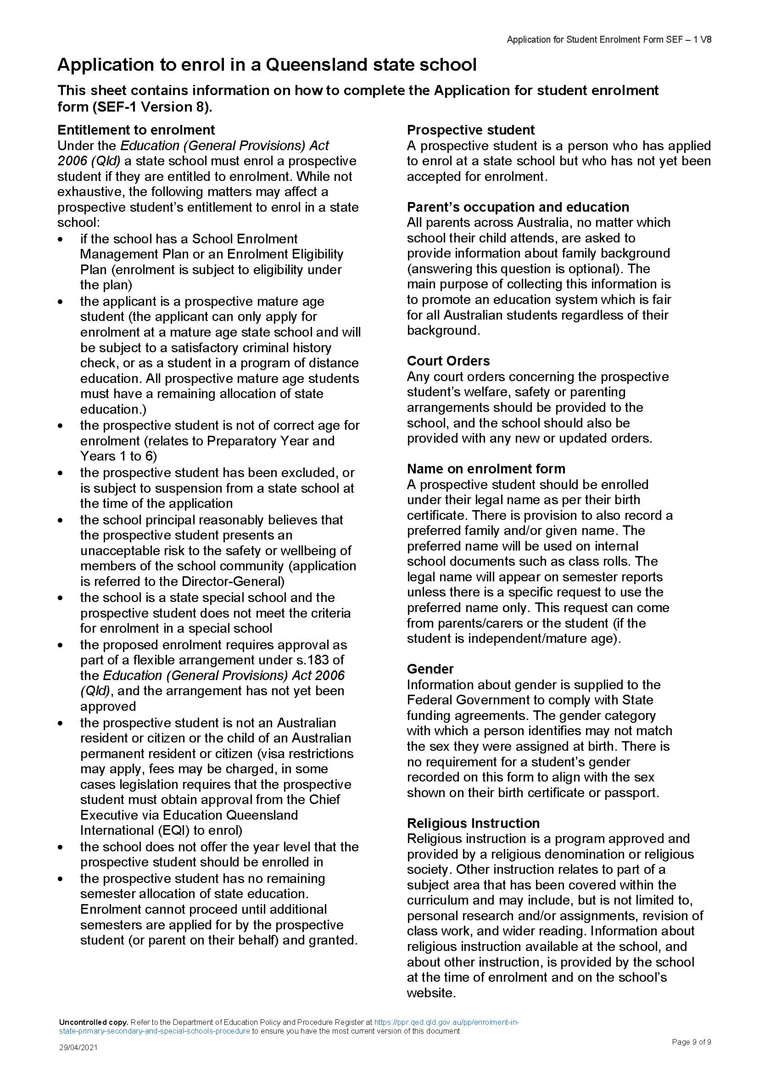
Behaviour & Internet Use Agreement

Redland Bay State School strives to provide a world class education that assists young Queenslanders to love learning, develop judgement and a sense of responsibility, understand the past and prepare them to embrace the future.

The foundation of our positive learning environment is established through the delivery of an inclusive and engaging curriculum, effective teaching and the development of respectful relationships among staff, students and parents.

All members of our school community are expected to conduct themselves in a lawful, ethical, safe and responsible manner that recognises and respects the rights of others.

The Code of School Behaviour requires all members of the community to meet positive and appropriate standards of behaviour at all times. The school will endeavour to deal with unacceptable behaviour in a supportive, constructive, fair, logical and consistent manner while ensuring individual circumstances are considered.

Behaviour Expectations

All students are expected to:
Participate actively in the school’s education program by being prepared, organized for and participating in all lessons
Take responsibility for their own behaviour and learning by knowing and adhering to school rules
Demonstrate respect for themselves, other members of the school community and the school environment by using appropriate language to students and adults at all times
Behave in a manner that respects the rights of others, including the right to learn by ensuring that the teaching of lessons is not disrupted
Co-operate with staff and others in authority and follow the directions of all staff members
Follow the school rules - Behave Respectfully; Behave Responsibly; Behave Safely

All parents/carers are expected to:
- Show an active interest in their child’s schooling and progress
- Co-operate with the school to achieve the best outcomes for their child
- Support school staff in maintaining a safe and respectful learning environment for all students
- Initiate and maintain constructive communication and relationships with school staff regarding their child’s learning, wellbeing and behaviour
- Contribute positively to behaviour support plans that concern their child.
Schools are expected to:
- Provide safe and supportive learning environments
- Provide inclusive and engaging curriculum and teaching Initiate and maintain constructive
communication and relationships with students and parents/carers
- Promote the skills of responsible self-management.
Internet Expectations
All students are expected to:
- Understand that the Internet can connect them to useful information stored on computers around the world. While they have access to the Internet they will use it only for educational purposes and will not look for anything that is illegal, dangerous or offensive.
- If they accidentally come across something that is illegal, dangerous or offensive, they will immediately clear any offensive pictures or information from their screen and
immediately, quietly, inform their teacher.
- They will not reveal their home addresses or phone numbers or anyone else’s.
- They will not use the Internet to annoy or offend anyone else.
- Understand that if the school decides they have broken these rules that the appropriate action will be taken. This may include loss of Internet access for some time.
All parents/carers are expected to:
- Understand that the Internet can provide students with valuable learning experiences.
- That it gives access to information on computers around the world; that the school cannot control what is on those computers; and that a very small part of that information can be illegal, dangerous or offensive.
- Except that, while teachers will always exercise their duty of care, protection against exposure to harmful information should depend finally upon responsible use by students.
Possible consequences of misconduct or disregarding the Behaviour Expectations may include but not be limited to the following:
- Immediate intervention and counselling by a staff member
- Timeout, setting of tasks, completion of work
- Communication with parents
Repeated disregard and /or offences may result in:
- In school withdrawal
- Loss of privileges
- Restorative action
- Temporary removal by staff of any inappropriate objects
- Suspension 1-5 days
- Suspension 6-20 days
- Behaviour Improvement Contract
- Recommendation for exclusion

Agreement

I accept the rules and regulations of the Redland Bay State School.

I acknowledge that information about the school’s current programs and services and where to gain access to this information has been provided to me.

We hereby agree to abide with Redland Bay State School’s and Education Queensland’s Code of School Behaviour.

Child’s Name:_______________________________ Signature:_____________________
Date:_____________

Parent’s Name:_______________________________ Signature:_____________________
Date:_____________
Enrolment Agreement

This enrolment agreement sets out the responsibilities of the student, parents or carers and the
school staff about the education of students enrolled at Redland Bay State School.

Responsibility of student to:
- attend school regularly, on time, ready to learn and take part in school activities
- act at all times with respect and show tolerance towards other students and staff
- work hard and comply with requests or directions from the teacher and principal
- abide by school rules, meet homework requirements and wear school’s uniform
- respect the school environment.

Responsibility of parents to:
- attend open evenings for parents
- let the school know if there are any problems that may affect your child’s ability to learn
- inform school of reason for any absence
- treat school staff with respect and tolerance
- support the authority and discipline of the school enabling your child to achieve maturity, self discipline and self control
- abide by school’s policy regarding access to school grounds before, during and after school hours
- advise Principal if your child is in the care of the state or you are the carer of a child in the care of the state
- inform school if your child’s living arrangements change and provide details of new home
address and phone number

Responsibility of school to:
- develop each individual student’s talent as fully as possible
- inform parents and carers regularly about how their children are progressing
- inform students, parents and carers about what the teachers aim to teach the students each term
- teach effectively and to set the highest standards in work and behaviour
- take reasonable steps to ensure the safety, happiness and self-confidence of all students
- be open and welcoming at all reasonable times and offer opportunities for parents and carers
- to become involved in the school community
- clearly articulate the school’s expectations regarding the responsible behaviour plan for
students and the school’s dress code policy
- ensure that parents and carers are aware of the school’s insurance arrangements and
accident cover for students
- advise parents and carers of extra-curricular activities operating at the school in which their
child may become involved, for example, Program of Chaplaincy Services; religious
instruction
- ensure that the parent is aware of the school’s record-keeping policy including the creation of a transfer note should the student enrol at another school
- set, mark and monitor homework regularly in keeping with the school’s homework policy
- contact parents and carers as soon as is possible if the school is concerned about the child’s
- school work, behaviour, attendance or punctuality
- deal with complaints in an open, fair and transparent manner
- consult parents on any major issues affecting students
- treat students and parents with respect and tolerance

Child’s Full Name: _____________________________________ D.O.B: ____________
By signing below, I acknowledge that information about the school’s current programs and services has been provided to me (Enrolment handbook).
I also accept the rules and regulations of the Redland Bay State School as stated in the school
policies that have been provided to me as follows:

□ Responsible Behaviour Plan for Students
□ Student Dress Code
□ Homework Policy
□ School Charges and Voluntary Contributions
□ Student usage of Internet, Intranet and Extranet
□ Absences
□ Health and Safety
□ School Excursions
□ Complaints Management
□ Department Insurance arrangements and Accident Cover for Students
□ Consent to use Copyright Material, Image, Recording or Name
□ Appropriate Use of Mobile Telephones and other Electronic Equipment by Students

Student Signature Parent/Carer Signature On behalf of Redland Bay State School
………………………………… ………………………..………… …………………………………………
Date: ……………….……… Date: ………….….…..……… Date: …………………………………

Anti Bullying

We agree to work together to improve the quality of relationships in our community at Redland Bay State School. It is through intentional consideration of our behaviour and communication that we can reduce the occurrence of bullying, and improve the quality of the schooling experience for everyone.

The agreed national definition for Australian schools describes bullying as
- ongoing and deliberate misuse of power in relationships through repeated verbal, physical and/or social behaviour that intends to cause physical, social and/or psychological harm;
- involving an individual or a group misusing their power, or perceived power, over one or more persons who feel unable to stop it from happening;
- happening in person or online, via various digital platforms and devices and it can be obvious (overt) or hidden (covert). Bullying behaviour is repeated, or has the potential to be repeated, over time (for example, through sharing of digital records);
- having immediate, medium and long-term effects on those involved, including bystanders. Single incidents and conflict or fights between equals, whether in person or online, are not defined as bullying.
We believe that no one deserves to be mistreated and that everyone regardless of race, colour, religion, immigration status, nationality, size, gender, popularity, athletic capability, academic outcomes, social ability, or intelligence has the right to feel safe, secure, and respected.

I agree to:
• Treat everyone with kindness and respect.
• Abide by the school's anti-bullying policies and procedures.
• Support individuals who have been bullied.
• Speak out against verbal, relational, physical bullying and cyber bullying.
• Notify a parent, teacher, or school administrator when bullying does occur.

Student Signature: __________________________________

Parent Signature: ______________________________

Date: _____________________

